Three murdered Aboriginal children... An investigation marred by racism... A 30-year battle for justice...
THE BOWRAVILLE MURDERS
Directed by Allan Clarke
In selected cinemas from September 2

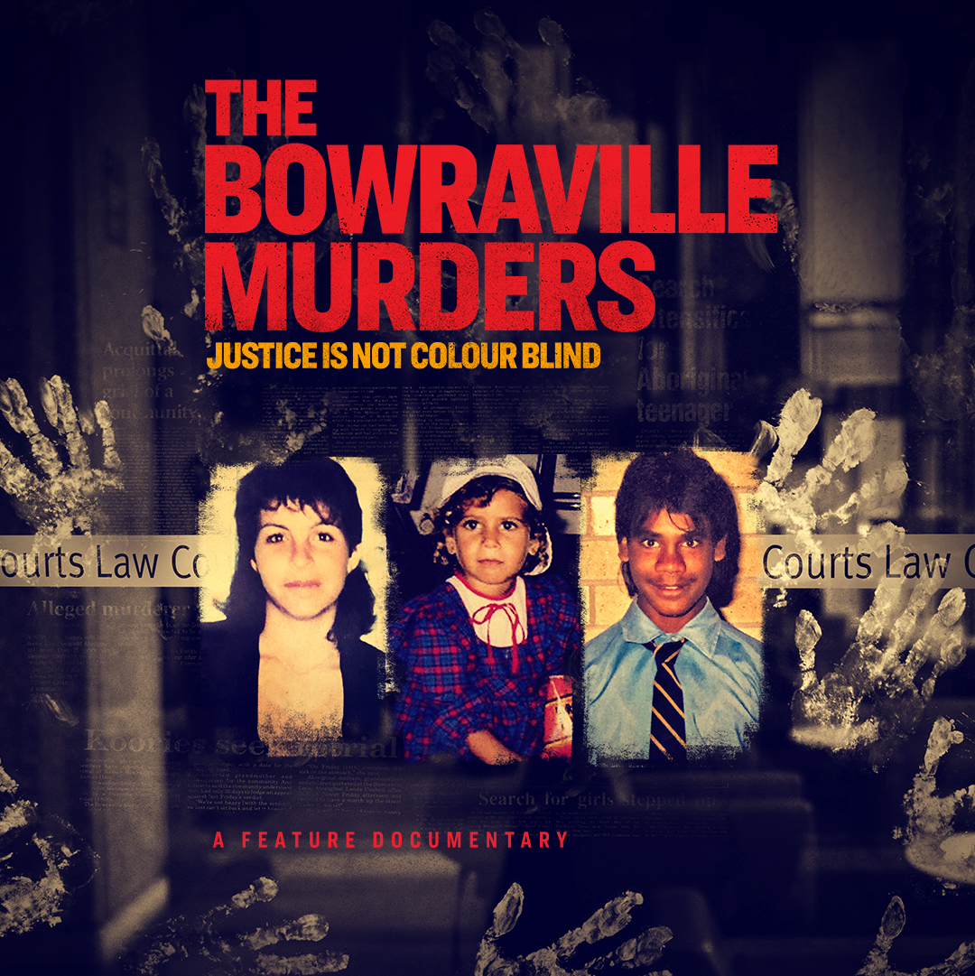
The Bowraville Murders, a feature documentary which investigates one of Australia’s worst unsolved serial murder cases, will be released in cinemas nationally from September 2 with a special world premiere screening at Majestic Cinemas, Nambucca Heads, on Sunday August 29.
In 1990-91 three kids disappeared from an Aboriginal Mission on the same street in Bowraville, a tiny country town in northern NSW: 16-year-old Colleen Walker-Craig, 4-year- old Evelyn Greenup, and 16-year-old Clinton Speedy-Duroux. Evelyn and Clinton’s remains were all found off the same dirt road, as were the clothes Colleen was wearing on the day she disappeared.
There has always been one suspect – a local white labourer who was acquitted for two of the murders after a botched, racially biased police investigation. To this day, the man maintains his innocence while the families desperately want him retried.
For 30 years the families of the murdered children have fought an epic Davis-versus-Goliath battle for justice, taking them from a remote Aboriginal Mission all the way to the High Court of Australia.
At the centre of this extraordinary battle and awe-inspiring endurance are the mothers and fathers, aunts and uncles of the three murdered children who are now passing the torch to the next generation.
The Bowraville Murders takes viewers on an emotional roller-coaster ride spanning 30 years as we follow the families through the carousel of courts all the way to the High Court of Australia, and extraordinary archive footage that documents the story from the time the children went missing...exactly 30 years ago.
Directed by award-winning journalist and Muruwari and Gomeroi man Allan Clarke, Stefan Moore and Dan Goldberg are co-producers and co-writers on the project. Adam Kay and Susan Lambert are executive producers.
The project is financed by SBS with support from Screen Australia and Screen NSW as well as philanthropy through the Documentary Australia Foundation.

View/embed trailer: https://youtu.be/4OCwnbs70dg

Press kit, stills HERE

Confirmed cinemas:
Vic:
Cinema Nova
Classic Elsternwick
The Lido
Cameo Belgrave

NSW:
Dendy Newtown – from September 9 (tbc)
Randwick Ritz
Majestic Nambucca Heads
Majestic Sawtell
Majestic Kempsey

SA:
Wallis Mitcham
Wallis Mt Barker

WA:
Luna Leederville

Additional cinemas to be confirmed. Details of Q&A screenings with director Allan Clarke will be confirmed in the coming days.

Media enquiries, including preview screening requests, please contact:
Tracey Mair l Ph: 0419 221 493 l E: traceym@tmpublicity.com

